Incident Title - Unauthorized Software Activation Attempt via External Media

Malware Prevention — KMSAuto Net.exe
Client: Primus | Prepared by: PKF Algosmic SOC | Date: 16 June 2026

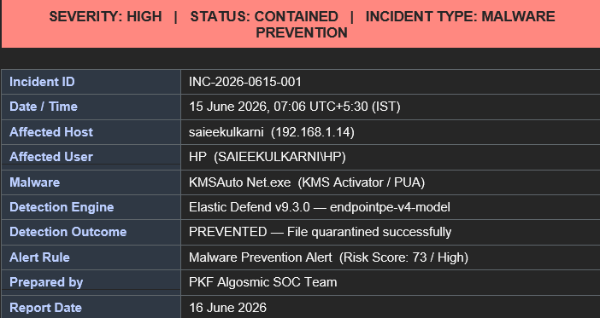

1. Executive Summary
On 15 June 2026 at approximately 19:33 IST, multiple high and critical security alerts were triggered on a Primus-managed Windows 10 workstation assigned to user HP on host saieekulkarni.
The investigation revealed that the user connected an external storage device (F:) and attempted to execute unauthorized software activation tools, including KMSAuto Net and Microsoft Activation Scripts (MAS_AIO), which are commonly used to bypass Microsoft licensing controls.
Elastic Defend successfully detected and blocked multiple execution attempts, quarantined the malicious files, and generated several critical alerts related to suspicious PowerShell activity associated with the activation process.
No evidence of successful malware execution, persistence, data theft, or lateral movement was identified during the investigation; however, the repeated use of unauthorized activation tools constitutes a violation of company policy and presents a significant security risk if such activity is not detected and prevented.

- Who: User HP on domain SAIEEKULKARNI operating a Windows 10 Home endpoint named saieekulkarni.

- What: Multiple attempts to execute unauthorized Microsoft activation tools (KMSAuto Net.exe and MAS_AIO.cmd) were detected and blocked by Elastic Defend. The activity also triggered multiple Critical "Suspicious PowerShell Execution" alerts associated with the activation process.

- When: 15 June 2026, 19:33–19:38 IST, with multiple execution and behavioral alerts generated during the activity window.

- Where: Host: saieekulkarni
IP Address: 192.168.1.14
Environment: Primus Windows environment monitored under the primus_windows_systems namespace.

- Why: The most likely intent was to bypass Microsoft Windows and Office licensing controls using unauthorized software activation utilities obtained from an external source.

- How: An external storage device (F:\) was connected to the endpoint. The user opened KMSAuto Net.rar using WinRAR, attempted to execute KMSAuto Net.exe, retried execution after the initial prevention action, subsequently launched PowerShell-based activation commands, and later executed MAS_AIO.cmd directly from the external drive. All malicious and suspicious activities were detected and blocked by Elastic Defend.
Business Impact

The security controls on the endpoint successfully detected and blocked all attempts to execute the unauthorized activation tools before any compromise could occur. However, this incident highlights a significant security concern, as the user repeatedly attempted to run software obtained from an untrusted external source. Tools such as KMSAuto Net and MAS_AIO are commonly distributed through unofficial channels and are frequently bundled with malicious code, including credential stealers, remote access trojans, and ransomware. In this case, no evidence of successful execution, persistence, lateral movement, or data exfiltration was identified. Nevertheless, had the activity not been prevented by Elastic Defend, the organization could have been exposed to malware infection, unauthorized access, or disruption of business operations. The incident also represents a violation of software usage and acceptable use policies and demonstrates the risk posed by introducing unauthorized software into the corporate environment.

2. Risk / Impact Analysis
- In this incident, all identified execution attempts were successfully blocked by Elastic Defend before the activation tools could run. The associated files were quarantined, and there is no evidence that persistence was established, credentials were compromised, or lateral movement occurred within the environment. While the immediate threat was contained, the activity still represents a significant security risk due to the nature of the tools involved and the methods used to execute them.

- The investigation identified repeated attempts to run unauthorized software activation tools, including KMSAuto Net and MAS_AIO, from an external storage device. In addition, multiple critical alerts were generated for suspicious PowerShell activity associated with the activation process. Such tools are commonly obtained from unofficial sources and are frequently modified or bundled with malicious payloads. Once executed, these programs can introduce malware, disable security controls, create unauthorized system modifications, or provide attackers with persistent access to the endpoint.

- Had the execution attempts not been prevented, the endpoint could have been exposed to credential theft, malware installation, unauthorized remote access, or ransomware-related activity. The use of PowerShell during the execution chain further increases the risk, as PowerShell is commonly leveraged to download additional payloads, modify system settings, or establish persistence. Although no evidence of successful compromise was identified during this investigation, the incident demonstrates how the introduction of unauthorized software can create a potential pathway for endpoint compromise.

- Based on the available evidence, the incident is assessed as a True Positive – Prevented Malware Execution. The overall business impact is low due to successful prevention; however, the underlying user activity presents a medium-to-high security risk and should be addressed through user awareness, software control policies, and continued endpoint monitoring.

3. Root Cause Analysis
The root cause of this incident was the user's attempt to run unauthorized software activation tools obtained from an external storage device on a corporate workstation. The activity originated when an external drive (F:) containing KMSAuto Net and MAS_AIO activation utilities was connected to the endpoint and used to execute software designed to bypass Microsoft licensing controls.

Technical Root Cause
- User HP connected an external storage device containing unauthorized activation tools to the workstation saieekulkarni.
- The user opened KMSAuto Net.rar using WinRAR, which extracted the contents to the user's temporary directory.
- The executable KMSAuto Net.exe was launched from the Temp folder, triggering Elastic Defend malware prevention controls.
- After the initial execution attempt was blocked, additional attempts were made to run the same tool, resulting in multiple prevention alerts.
- The activity subsequently generated several Critical Suspicious PowerShell Execution alerts, indicating that command-line and PowerShell-based activation scripts were also being executed.
- The user later launched MAS_AIO.cmd directly from the external drive, representing another attempt to activate Microsoft products using unauthorized methods.
- Elastic Defend successfully detected and blocked all identified execution attempts before successful execution could occur.

Contributing Factors
- The endpoint permitted the use of external USB / removable storage devices without restriction.
- Unauthorized software was introduced from an untrusted external source into the corporate environment.
- The user attempted to execute software activation tools that are commonly distributed through unofficial websites, forums, and file-sharing platforms.
- PowerShell and command-line interpreters were leveraged during the activation process, increasing the security risk associated with the activity.
- No application control or execution restriction policy was in place to prevent the execution of unauthorized scripts and executables from removable media or temporary directories.

Root Cause Conlusion
The incident was caused by the introduction and attempted execution of unauthorized software activation tools from external media by an end user. While endpoint protection controls successfully prevented execution and quarantined the detected files, the activity highlights weaknesses in removable media governance, software usage compliance, and user awareness regarding the risks associated with unlicensed software and unofficial download sources.

4. Detailed Technical Investigation
4.1 Process Execution Chain
- The activity began at approximately 19:33 IST when the user initiated the execution of an unauthorized software activation utility from an external storage device mounted as F: , The process chain originated from explorer.exe, the standard Windows shell process running under the logged-in user HP, which launched WinRAR.exe after the user opened the archive file KMSAuto Net.rar.
- At 19:33:34 IST, WinRAR.exe (PID 5780) attempted to launch KMSAuto Net.exe (PID 9152) from the extracted archive contents. Elastic Defend evaluated the executable during process creation and immediately classified it as malicious. The execution attempt was blocked, and the file was prevented from running on the endpoint. During the same timeframe, a related file creation event associated with the extracted executable was also detected and blocked. Telemetry confirms that both events originated from the same archive extraction and execution workflow involving KMSAuto Net.rar located on the external drive.

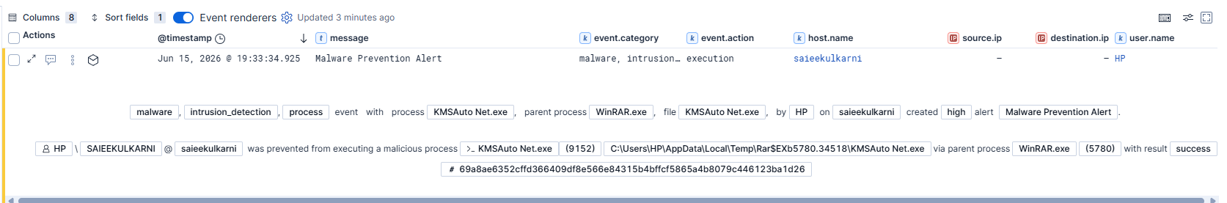

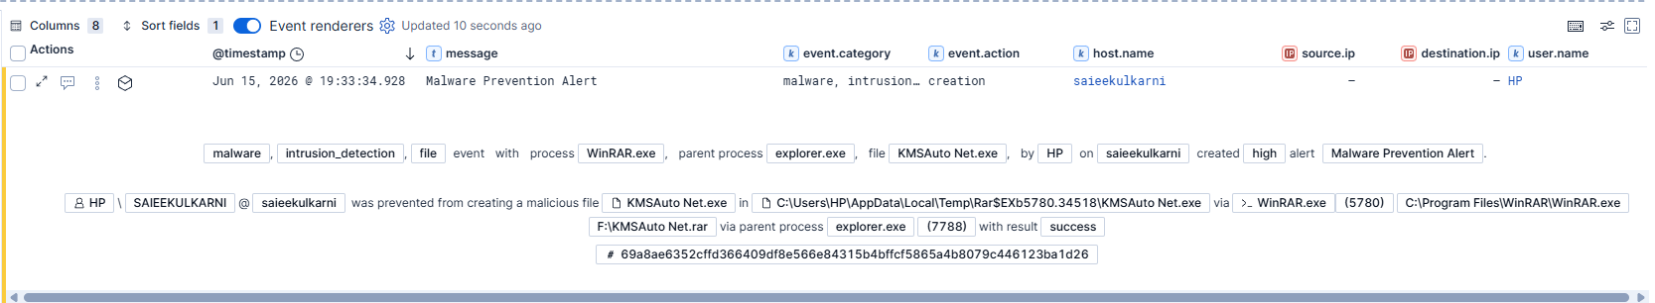

- At 19:34:33 IST, a second execution attempt involving KMSAuto Net.exe was observed. This time, the executable was launched through a separate WinRAR process instance (PID 596), resulting in a new child process (PID 7944). Elastic Defend again intercepted the execution attempt and prevented the file from running. The change in process identifiers confirms this was a separate execution attempt rather than a duplicate alert generated from the original event.
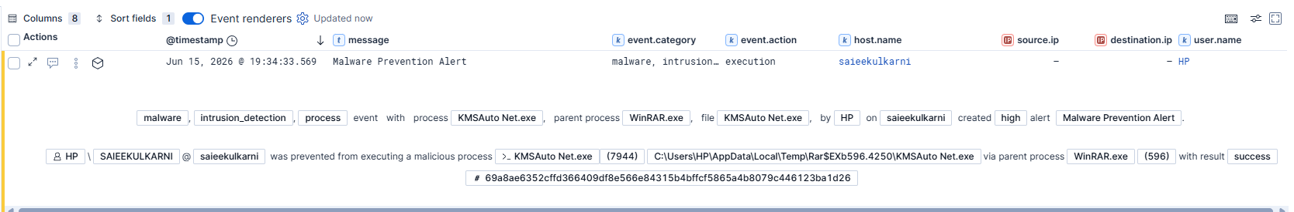

- Immediately following the second blocked execution attempt, multiple Critical "Suspicious PowerShell Execution" alerts were generated. Telemetry indicates that powershell.exe was launched through cmd.exe, suggesting that PowerShell-based activation scripts or supporting commands were executed as part of the software activation process. Multiple alerts were generated within seconds of each other, indicating behavioral detections associated with the same PowerShell activity chain rather than separate unrelated incidents.

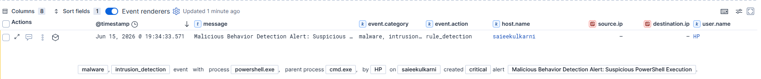

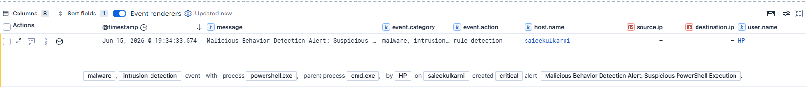

- At 19:38:12 IST, additional activity was observed when cmd.exe (PID 10636), launched by explorer.exe, executed F:\Activator\MAS_AIO.cmd directly from the external storage device. MAS_AIO (Microsoft Activation Scripts) is another commonly used software activation utility. This indicates that after the KMSAuto execution attempts were blocked, the user switched to an alternative activation method in an attempt to continue the software activation process.
- Throughout the observed activity window, Elastic Defend successfully detected and blocked all identified malicious and suspicious execution attempts. No evidence was identified indicating successful malware execution, persistence establishment, privilege escalation, credential access, or lateral movement beyond the local endpoint.

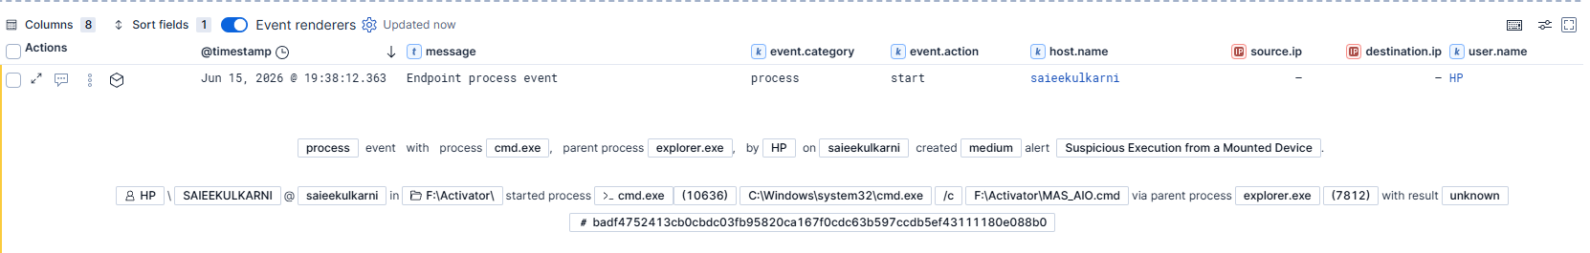

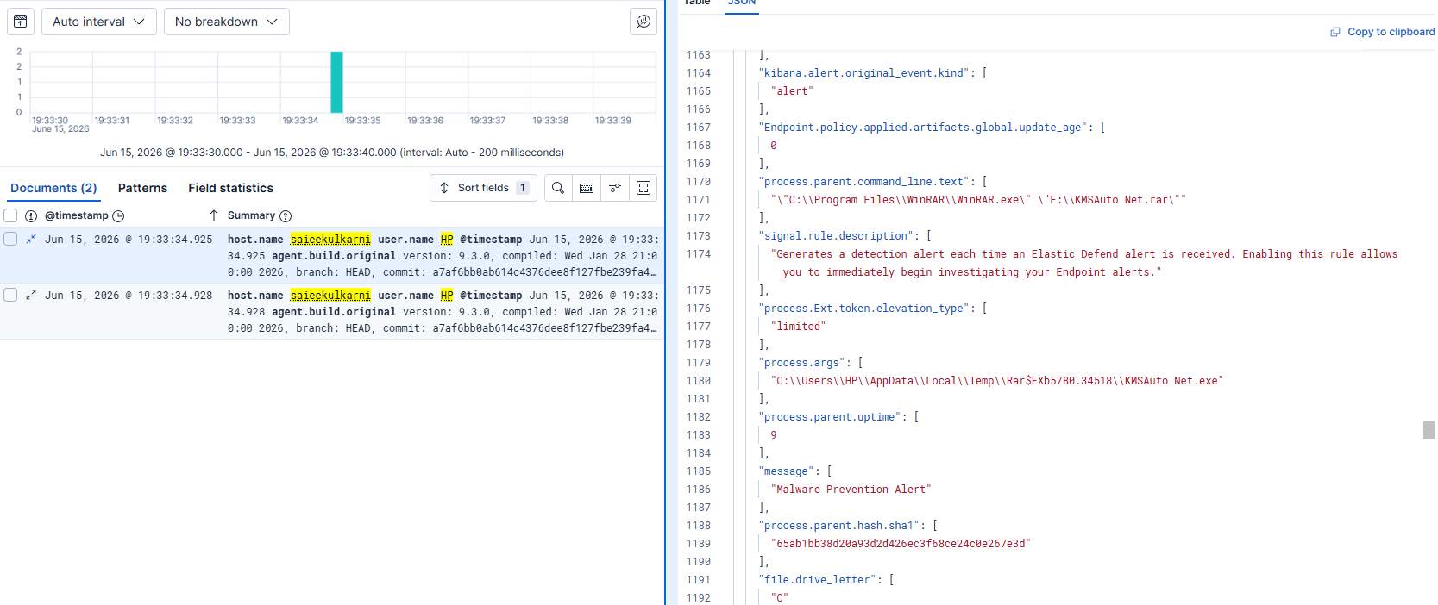

4.2 File Artifact Analysis
The primary file involved in the incident was KMSAuto Net.exe, an unauthorized software activation utility extracted from the archive KMSAuto Net.rar located on the external drive F:. The executable was written to a temporary extraction directory and subsequently attempted to execute multiple times before being blocked by Elastic Defend.

Key forensic indicators associated with the file include:

● SHA-256 Hash: 69a8ae6352cffd366409df8e566e84315b4bffcf5865a4bffcf5865a4b8079c446123ba1d26
● File Name: KMSAuto Net.exe
● Source Archive: KMSAuto Net.rar
● Execution Source: External Storage Device (F:)
● Execution Location: User temporary extraction directory

The file was identified by Elastic Defend as malicious during execution attempts and generated Malware Prevention Alert detections. Elastic's machine learning engine assigned the file an extremely high malicious classification score, resulting in immediate prevention and quarantine actions. The executable was associated with software activation activity and exhibited behavior consistent with unauthorized licensing bypass tools commonly distributed through unofficial software sources.
In addition to KMSAuto Net.exe, the investigation identified the execution of MAS_AIO.cmd from the external storage device. MAS_AIO is another software activation utility frequently used to bypass Microsoft licensing mechanisms. The presence of multiple activation tools on the same removable media indicates deliberate attempts to activate software through unauthorized methods rather than a single accidental execution event.
No evidence was identified indicating successful payload execution, secondary malware deployment, persistence creation, or post-exploitation activity associated with either file during the investigation period.

4.3 Event Correlation
Analysis of the alerts confirms that all events are part of a single activity sequence involving the same user (HP), endpoint (saieekulkarni), and external storage device (**F:**). The activity began with the extraction and execution attempts of KMSAuto Net.exe through WinRAR, which were blocked by Elastic Defend. A second execution attempt was observed shortly afterward, followed by multiple Critical Suspicious PowerShell Execution alerts related to the activation process. The final event involved the execution of MAS_AIO.cmd from the same external drive after the KMSAuto attempts were prevented. Based on the timeline, process relationships, and execution sources, all alerts are correlated to a single user-driven software activation attempt rather than separate security incidents. The activity is classified as a True Positive, and all execution attempts were successfully blocked by endpoint security controls.

4.4 MITRE ATT&CK Mapping
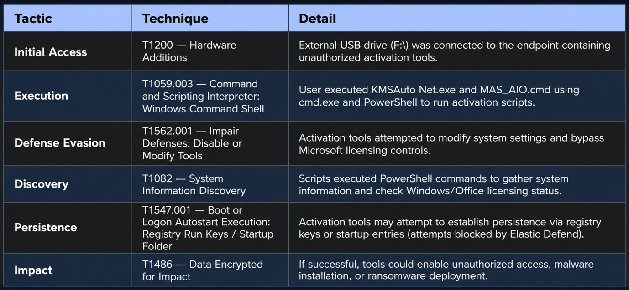

5. Incident Timeline
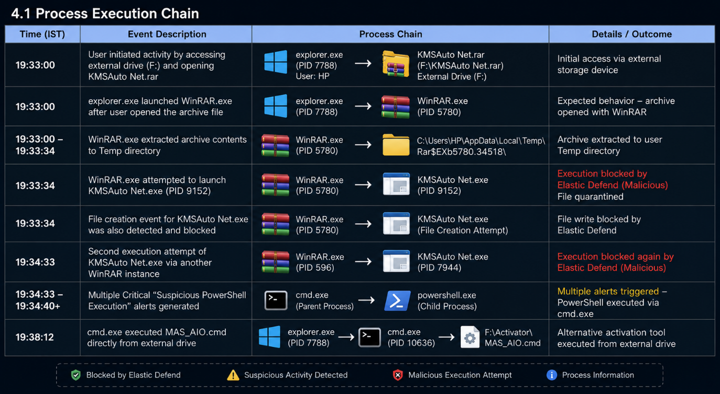

6. Indicators of Compromise (IOCs)
SHA256
- 69a8ae6352cffd366409df8e566e84315b4bffcf5865a4b8079c446123ba1d26

Files
- KMSAuto Net.exe
- KMSAuto Net.rar
- MAS_AIO.cmd

Paths
- F:\KMSAuto Net.rar
- F:\Activator\MAS_AIO.cmd
- C:\Users\HP\AppData\Local\Temp\Rar$EXb5780.34518\KMSAuto Net.exe
- C:\.equarantine\738947bc-c9ca-4fba-8410-a4a0dd17e94c

Processes
- WinRAR.exe
- KMSAuto Net.exe
- cmd.exe
- powershell.exe
- MAS_AIO.cmd

Alerts
- Malware Prevention Alert
- Suspicious PowerShell Execution

7. Actions Taken by PKF Algosmic SOC Team
Upon detection of the Elastic Defend high-severity alert, the PKF SOC team undertook the following response actions:
- Alert Triage & Validation: The alert was reviewed and triaged by the PKF SOC analyst. The alert reason, process chain, file hash, ML score, and code signature were all examined to confirm this was a true positive malware detection and not a false positive. The alert was acknowledged in Kibana (workflow_status: acknowledged).
- Threat Intelligence Enrichment: The file hash (SHA-256: 69a8ae6352…) was cross-referenced against threat intelligence sources to confirm the file's classification as a KMS activator / PUA with widespread AV detections. The code signer 'Ratiborus MSFree Inc.' was validated as a known cracked software distributor.
- Quarantine Confirmation: The PKF SOC team confirmed that Elastic Defend had successfully quarantined the primary executable to C:\.equarantine\738947bc-c9ca-4fba-8410-a4a0dd17e94c. The quarantine result for the primary execution event was confirmed as 'Success'.
- Containment Assessment: An assessment was performed to determine whether any secondary processes, persistence mechanisms, or network connections were established prior to or during the blocked execution. Based on available telemetry, no post-execution activity was observed — the execution was blocked at the point of launch.
- Incident Documentation: A full incident report (this document) was prepared, documenting the complete attack chain, IOCs, timeline, and recommendations for submission to the Primus client team.
- Escalation: The incident was escalated to the Primus client team for awareness, with recommended immediate and long-term remediation actions.

8. Long-Term Recommendations
The following recommendations address the root causes of this incident and are designed to prevent recurrence at a structural and policy level:
9.1 USB & Removable Media Policy Enforcement
- Implement device control policies via the Elastic Defend policy (or a dedicated MDM/GPO solution) to restrict or audit USB storage device usage on corporate endpoints. At minimum, enforce a policy requiring IT approval before external drives can be used on domain-joined machines. This directly eliminates the physical access vector exploited in this incident.
9.2 Application Whitelisting / Execution Control
- Deploy application whitelisting using Windows Defender Application Control (WDAC) or AppLocker to prevent the execution of unsigned or untrusted binaries, particularly from high-risk directories such as %TEMP%, %APPDATA%, and removable drives. This would have independently blocked this execution even if the EDR classification had failed.
9.3 Software Asset Management & Licensing Compliance
- Establish a formal Software Asset Management (SAM) program to ensure all software used within the Primus environment is properly licensed and sourced through approved channels. Remove any unlicensed or evaluation software from endpoints. Enforce an IT-managed software catalog for approved applications.
9.4 Security Awareness Training
- Conduct mandatory security awareness training focused on the dangers of pirated software, unauthorized downloads, and the use of external media. Employees should understand that cracked software, key generators, and activation tools are extremely high-risk vectors for malware infection — frequently used by threat actors as initial access mechanisms.
9.5 Threat Hunting Program
- Establish a proactive threat hunting cadence using Kibana to periodically hunt for indicators of piracy tools, dual-use utilities, and unauthorized software across the primus_windows_systems namespace. Detection queries should target known KMS activator hashes, Ratiborus code signatures, and execution from Temp directories.
9.6 Exploit & Execution Prevention Hardening
- Enable additional Elastic Defend protection features including memory threat protection and behavior-based prevention for credential access patterns. These features, if not already enabled at the maximum prevention level, add further layers of protection that would catch post-execution activity even if initial execution were somehow to succeed.

